*By****:*** *1. Hiliwi Leake KIDANE*

*2. Mohamed ELSAYED ELAWADY ABDELAZIZ*

Group: **GrTPB1**

November 9, 2012

**Objectives:**

The objective of this laboratory was to study moving object imaging techniques. Specifically, we studied:

* How to capture images of moving objects at different speed
* How to affect imaging of moving object by introducing external triggering frequency
* How to affect the exposure time of line Scanning camera using external triggering
* How to calibrate our camera and set it in the correct position to get real image of the moving object.

**Equipment Used:**

* PC Computer
* Frame Grabber : DALSA XCELERA-CL LX1
* Digital Camera: DALSA S2-1X-02K40
* 50 mm Lens: PENTAX YF5028A-02
* Video Cables
* 12V Power Supply
* Moving Industrial Parts
* Signal Generator
* Oscilloscope

**Software used:**

* CamExpert – TELEDYNE DALSA

**Documentation used:**

* User Manual & Brochure for camera & frame grabber
* Lectures on Machine Vision

In this laboratory, we did two experiments. The first experiment was grabbing images without the use of any external triggering system and the second was using external triggering. Now let’s see what we observed from the two experiments one by one.

***Experiment-I***

To start the first experiment, first we connected the Line scanning camera to the computer. Then we have switched on the backlight of the imaging plane and the moving industrial motor, after that we started the CamExpert-TELEDYNE DALSA software and opened the DALSA XCELERA-CL LX1 file to start grabbing images as shown in figure 1 and 2. In this part of the experiment, we captured images of moving objet without the use of any external triggering systems to the grabbing software that is we captured image of moving object using default line scanning configuration of the software without considering the speed of the moving object.

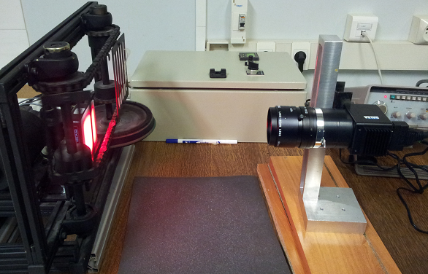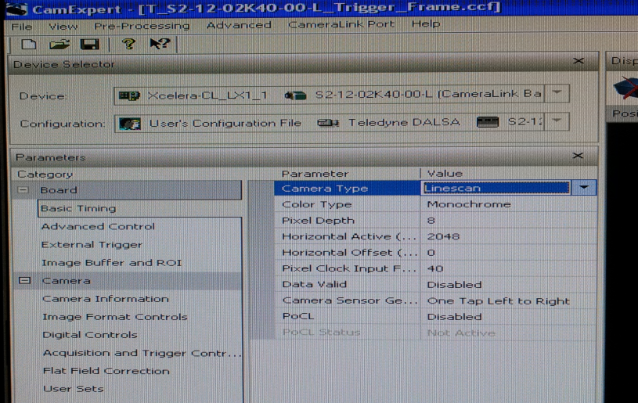

Fig 1. Industrial rotating object & camera Fig 2. CamExpert-TELEDYNE DALSA software

We have adjusted the position of the camera and the size of its *Aperture* and *Lens* until we get a good picture and also we changed the speed of the moving object and we observed different images at different speed. The following pictures show the images we have captured at different speed of the moving object.





Fig 3. Image captured when the object is Fig 4. Image captured when the object is moving

moving fast. relatively slow

**Observation and Analysis:**

As we observe from the above two pictures taken at different speed of the moving object, the picture of the object taken when moving slowly is better than the picture taken when moving fast. However, both images do not actually represent the actual size of the scene we want to capture and it was very difficult to captured and identify the written letters in the moving object. The main reason for that was the camera that we were using is a *line scanner (*512 / 1024 / 2048 *resolution,* 65 / 35 / 18 kHz *Max. Line/Frame Rate)*, that has a high dynamic range and operate at a data rate of up to 40MHz per output.

This camera scans a *single line* at a given time and continues to scan the whole scene sequentially. Since the scene that we were capturing is moving, the successive scans do not actually represent the moving scene; rather, they are just under sampled versionof the actual scene. Therefore, we do not get the actual size of the moving object. The problem becomes visible when the speed of the scene is faster relative to the line scanning rate of the camera as we see in the above pictures. But we can solve this problem by introducing external triggering system that affects the behavior of the line scanning camera or in the other words we can solve this problem by changing the line scanning of the camera by introducing external frequency. The details of the process and outputs of the line scanning after introducing external triggering frequency is presented below in the experiment II.

***Experiment-II***

In this part of the experiment, we solved the problem of under-sampling of the same camera using external triggeringsignaling mechanism. To do this, first we have adjusted the required frequency by connecting the signal generator to the oscilloscope. After that, we connected the output of signal generator to the computer and then we changed the configuration of the CamExpert software to its external triggering mode and then switched on the backlighting and industrial motor to start grabbing.

The goal of this external triggering frequency is to make the line scanning rate of the camera as enough as possible to avoid the effect of speed of moving scene. Consequently, the camera will scan as much enough samples as possible to represent the actual scene of the moving object. And also we proved that by changing the duty cycle of the triggering frequency it is possible to affect the exposure time of the line scanning camera.

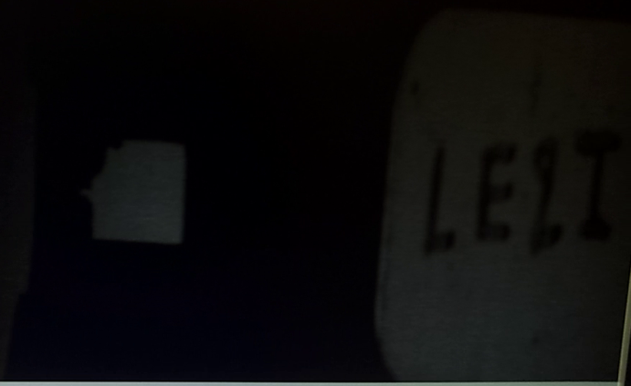  
Fig 5. Picture of moving object at 18KHz Fig 3. Picture taken at low Duty Cycle

External triggering frequency

**Observation and Analysis:**

The main observation that we saw in this experiment is, as we increase the frame rate of the camera by introducing external frequency, the camera line scanning operation overcomes the moving speed of the scene and it would have enough time to take samples to represent the equivalent scene on the camera sensors. At the same time as we vary the duty cycle of the external triggering signal, we are affecting the camera exposure time. for

Conclusion:

In conclusion, this lab gave us a clear and rigorous picture of the concept of moving object imaging using standard line scanner camera. Moreover, we have seen how camera designs and settings affect the result of the images that we can capture and how to apply these principles for industrial inspection.